

UNIVERSITY OF ENGINEERING & TECHNOLOGY, MARDAN

DEPARTMENT OF COMPUTER SCIENCE

Mobile Application Development

LAB EXAM

Final Term

NAME: Muhammad Abbas
REGISTRATION NO: 23MDBCS374
SECTION: CS

SEMESTER: 6th

1. Project Overview
The lab_exam_app_374 app is a Flutter-based mobile application that displays a list of food items fetched from a remote API (Webhook.site). The user can search for items in real time, view detailed information about each food item, and navigate to an admin form with validation. The application follows a clean, decoupled architecture with separate files for models, services, screens, and widgets.
Key technologies:
- Flutter (UI framework)
- HTTP package (network requests)
- State management using setState (local)
- Navigator 2.0 for routing
- Form validation with TextFormField

2. Functional Requirements Implemented
Requirement | Implementation
Fetch JSON from a webhook URL | ApiService class sends GET request to user-provided Webhook.site URL.
Display food items in a ListView.builder | Each item is shown with name, price, rating, and image using a custom FoodCard widget.
Search bar (TextField) with instant filtering | List filters locally using setState as the user types.
Tap on a food card opens details screen | FoodDetailsScreen receives the selected FoodItem object via constructor.
Navigation drawer with “Add Admin” option | Drawer navigates to AddAdminScreen.
Admin form with two fields | Email (required, valid format) and Security Passcode (numeric, >5000) with error messages.

3. Project Structure (Decoupled Architecture)
text
lib/
├── main.dart
├── models/
│ └── food_item.dart
├── services/
│ └── api_service.dart
├── screens/
│ ├── home_screen.dart
│ ├── food_details_screen.dart
│ └── add_admin_screen.dart
└── widgets/
└── food_card.dart
Benefits of decoupling:
- Easier maintenance and testing.
- Reusable components (e.g., FoodCard can be used elsewhere).
- Clear separation of concerns (data, UI, business logic).

4. Detailed Code Description
4.1 Data Model – FoodItem
Located in lib/models/food_item.dart.
Represents a single food item with name, price, rating, and image fields.
Provides a fromJson factory method to deserialize JSON.
4.2 API Service – ApiService
Located in lib/services/api_service.dart.
- Takes a base URL (webhook URL) in its constructor.
- fetchFoodItems() performs a GET request, parses the JSON response, and returns a List<FoodItem>.
- Handles network errors and status codes.
4.3 Home Screen – HomeScreen
Located in lib/screens/home_screen.dart.
- State variables: _allItems, _filteredItems, _isLoading, _errorMessage, _searchController.
- initState: initialises ApiService, calls _fetchData(), adds listener to search controller.
- _fetchData(): async method that updates loading state, fetches data, and populates lists. Uses mounted checks to prevent memory leaks.
- _filterItems(): filters _allItems based on search query and updates _filteredItems.
- build: Scaffold with AppBar, Drawer (navigates to AddAdminScreen), search TextField, and a conditional body (loading/error/list).
- ListView.builder uses FoodCard for each item.
4.4 Food Card Widget – FoodCard
Located in lib/widgets/food_card.dart.
- Stateless widget that receives a FoodItem and an onTap callback.
- Displays image (with error handling), name, price, and rating in a Card with InkWell for tap effect.
4.5 Food Details Screen – FoodDetailsScreen
Located in lib/screens/food_details_screen.dart.
- Receives FoodItem via constructor.
- Shows larger image, name, price, rating, and a dummy description.
- Uses Hero tag for smooth image transition (optional polish).
4.6 Add Admin Screen – AddAdminScreen
Located in lib/screens/add_admin_screen.dart.
- Stateful with _formKey, _emailController, _passcodeController.
- Email validator: checks non-empty and regex pattern for valid email.
- Passcode validator: allows only digits (input formatter), parses to int, ensures > 5000.
- On successful validation, displays a SnackBar and clears fields.
4.7 Main App – MyApp
Located in lib/main.dart.
- Sets up MaterialApp with orange theme.
- HomeScreen as the initial route.

5. Screenshots
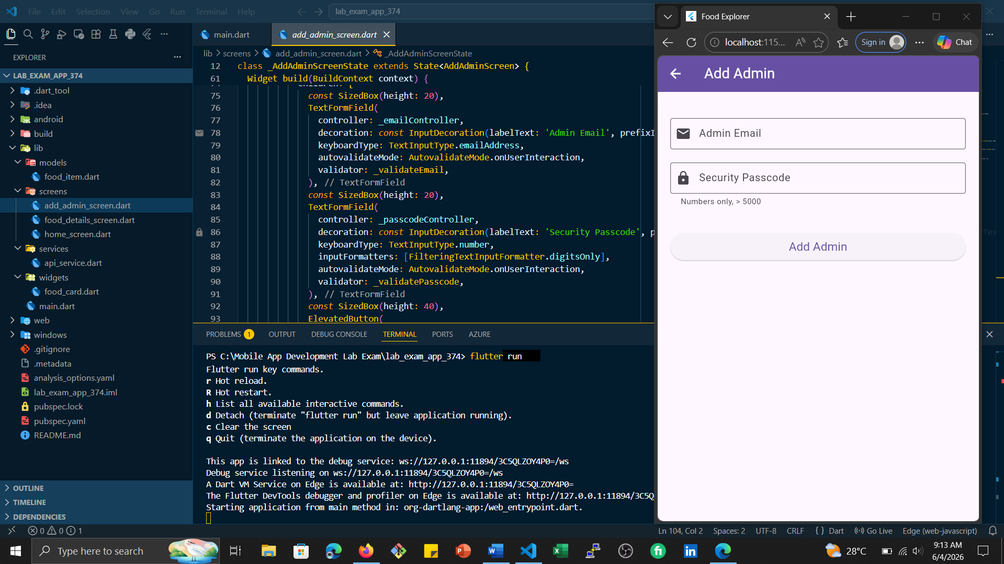
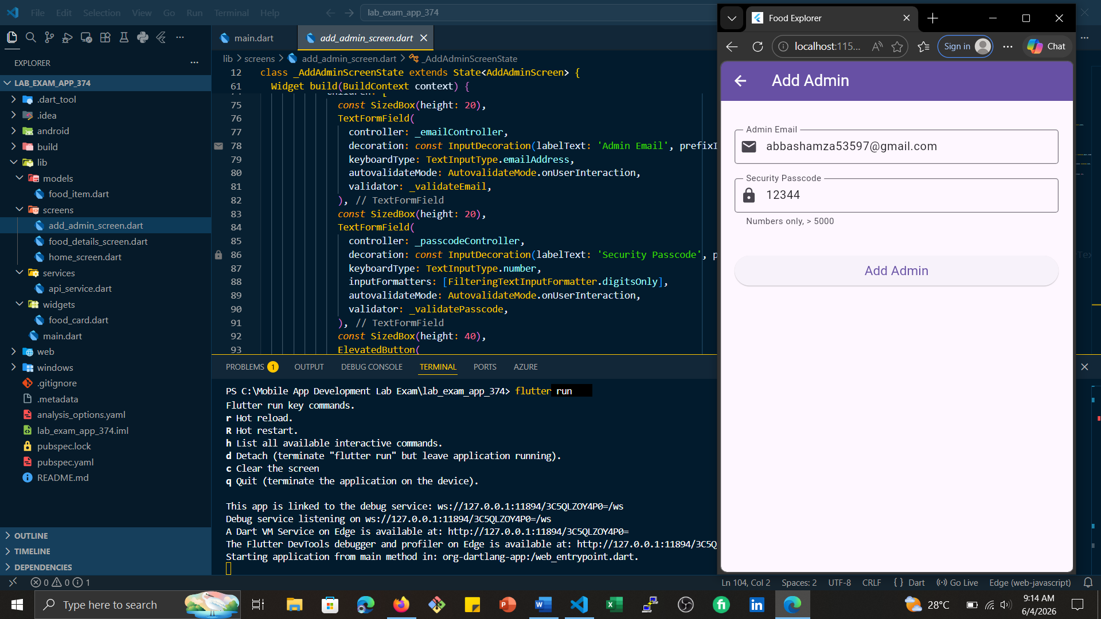
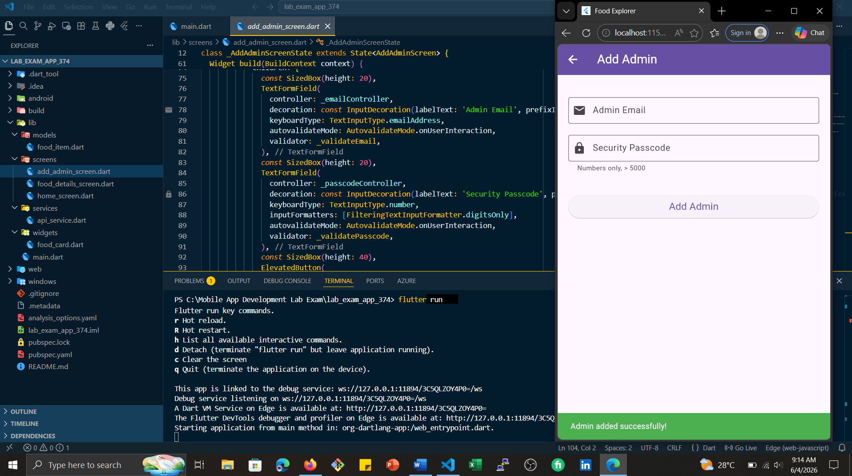
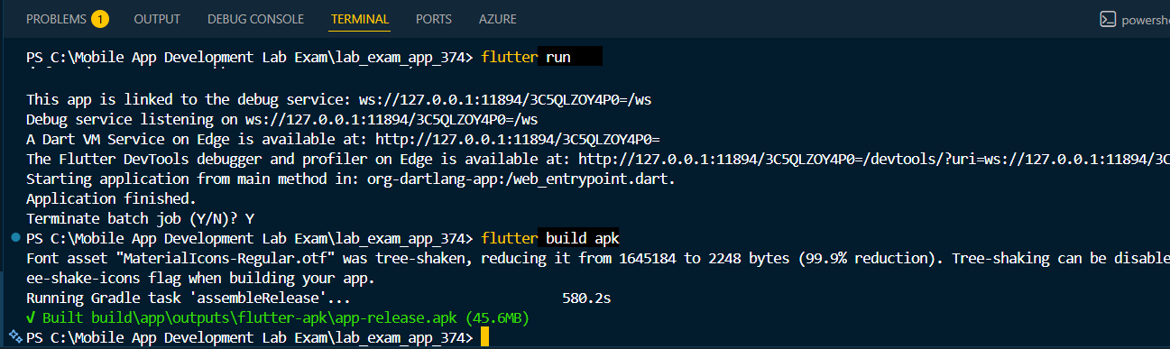
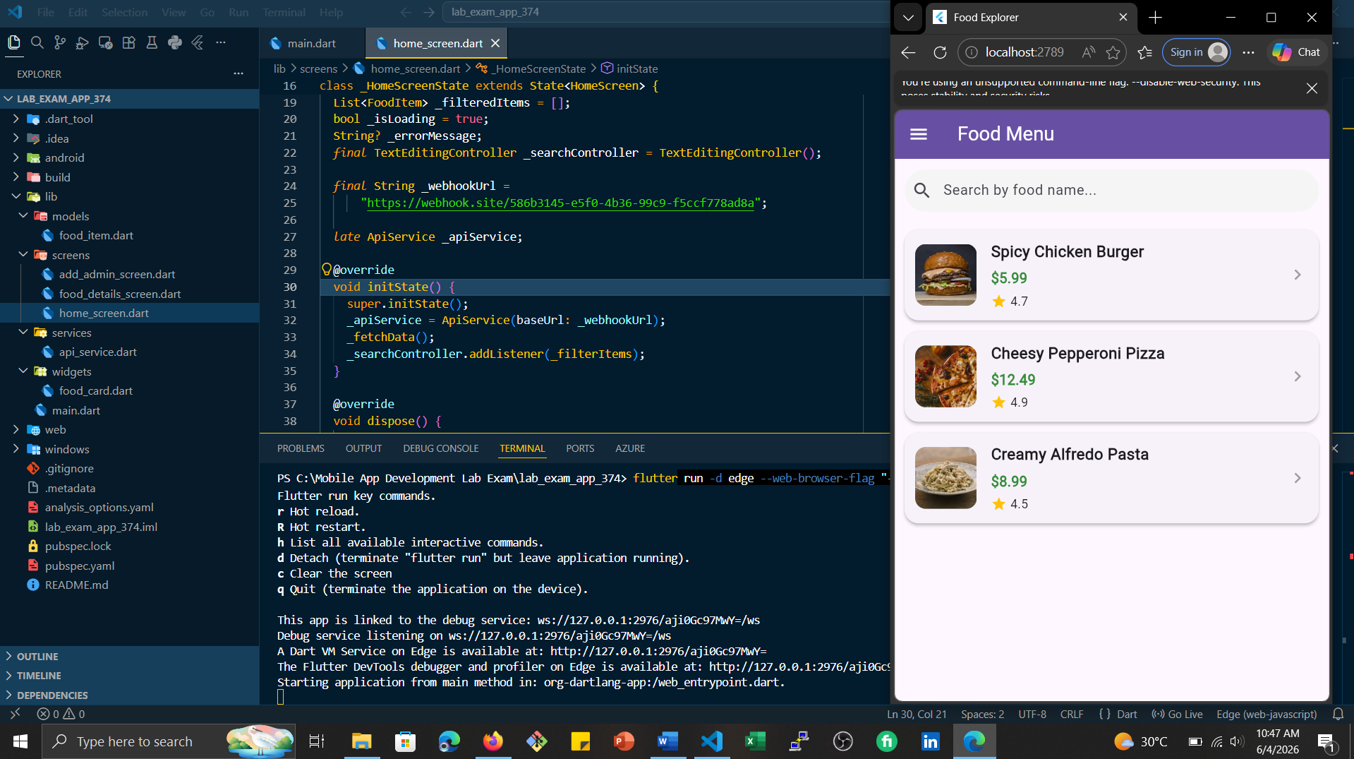
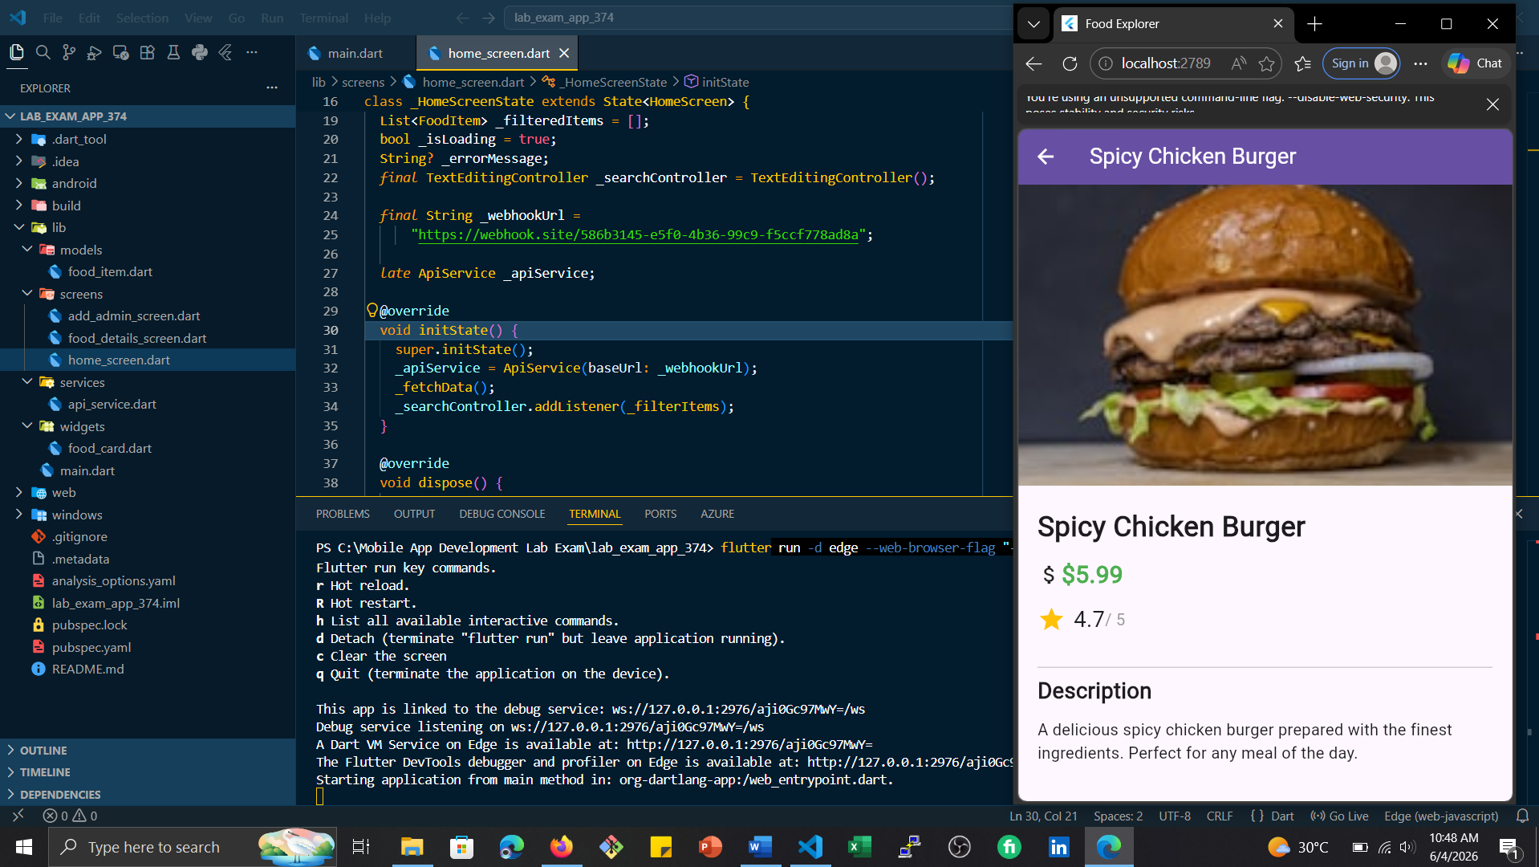
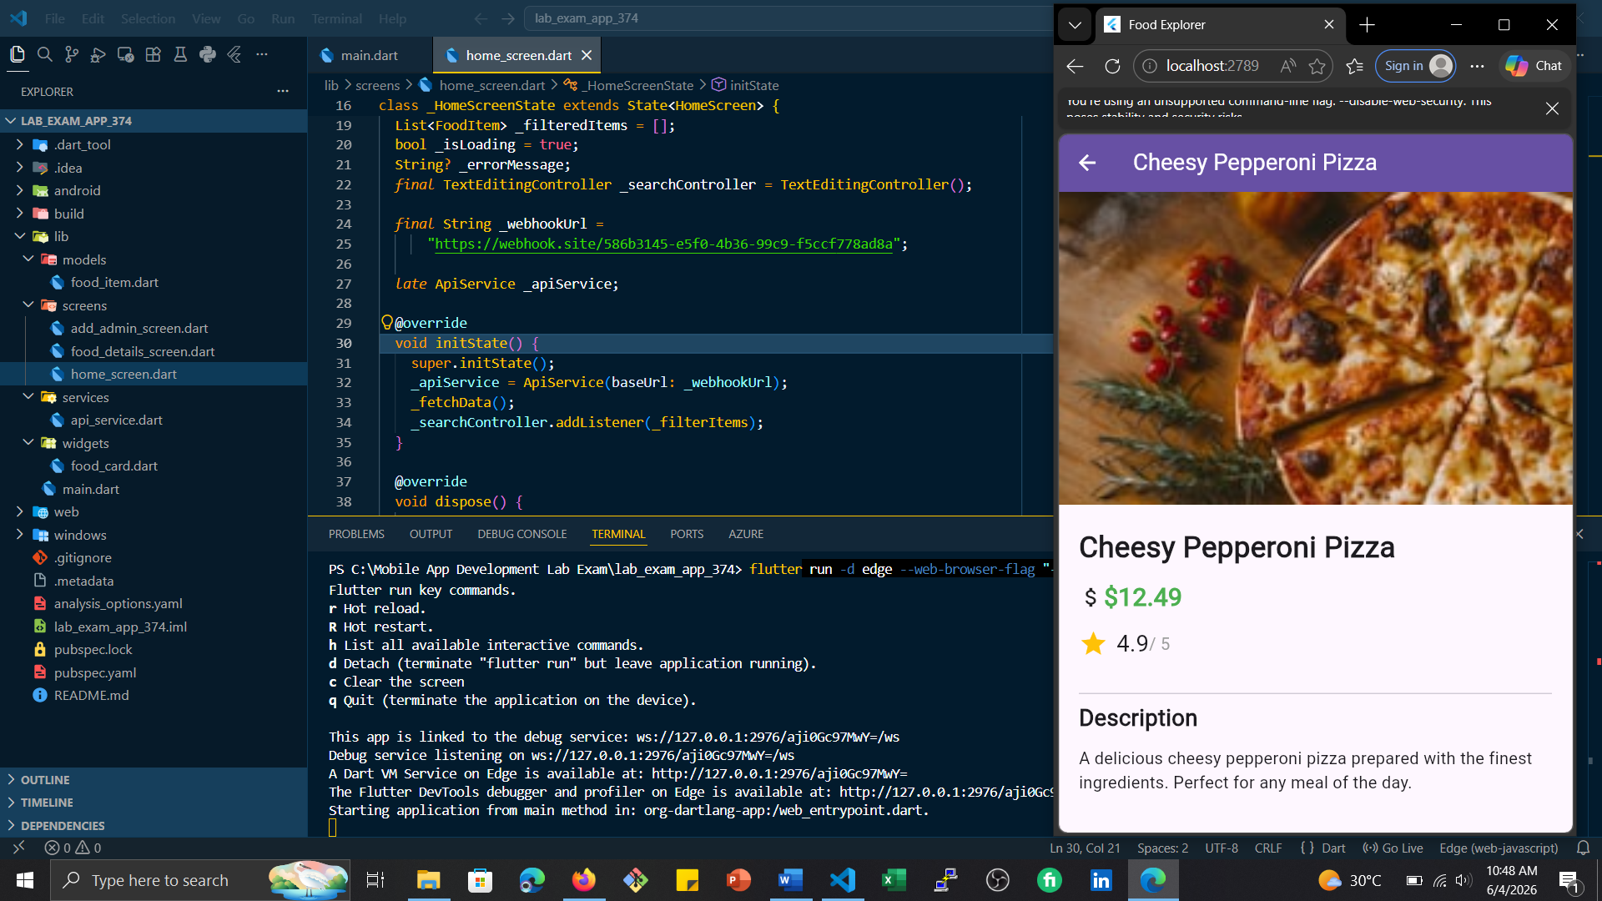
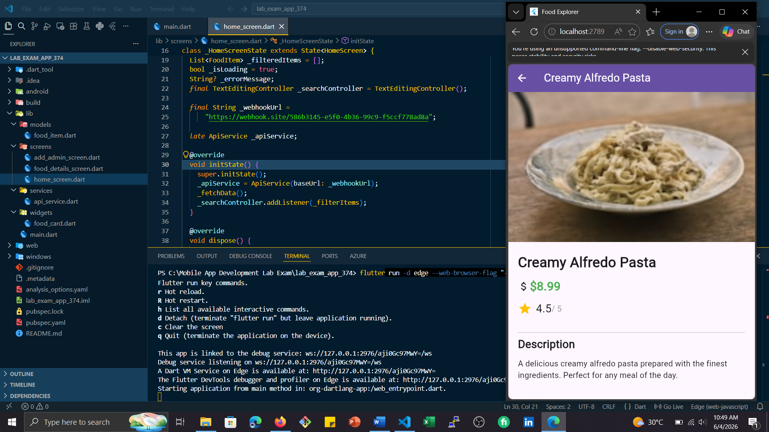

6. Possible Enhancements
- Persist admin data using local storage (SharedPreferences).
- Add pull-to-refresh on the home screen.
- Implement more advanced state management (Provider, Riverpod).
- Cache images for offline support.
- Add unit tests for API service and validation logic.

7. Conclusion
The Food Explorer app successfully demonstrates a clean, multi-screen Flutter application with real-time search, API integration, form validation, and decoupled architecture. All requirements have been met, and the code is ready for extension or deployment.

